**Lab 5 Report**

**Pre-lab Exercise**

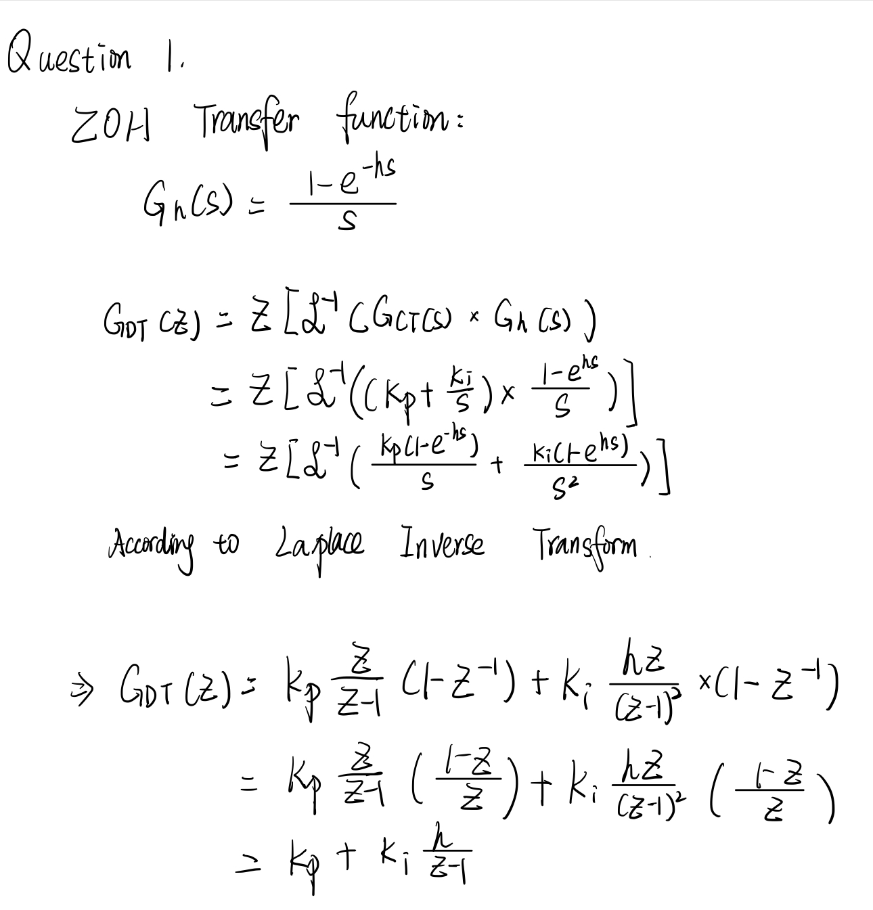

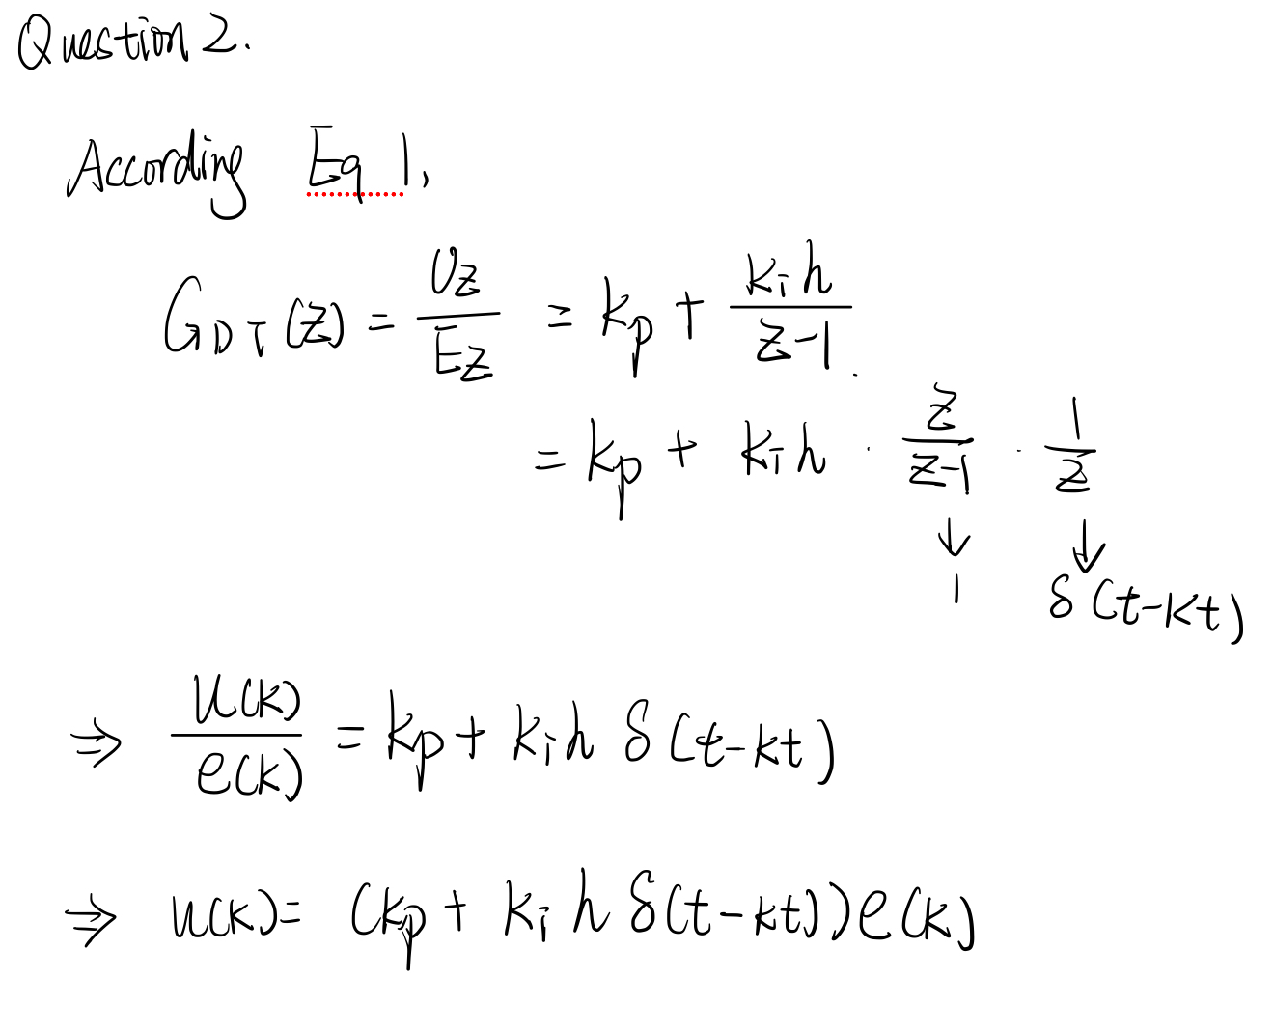

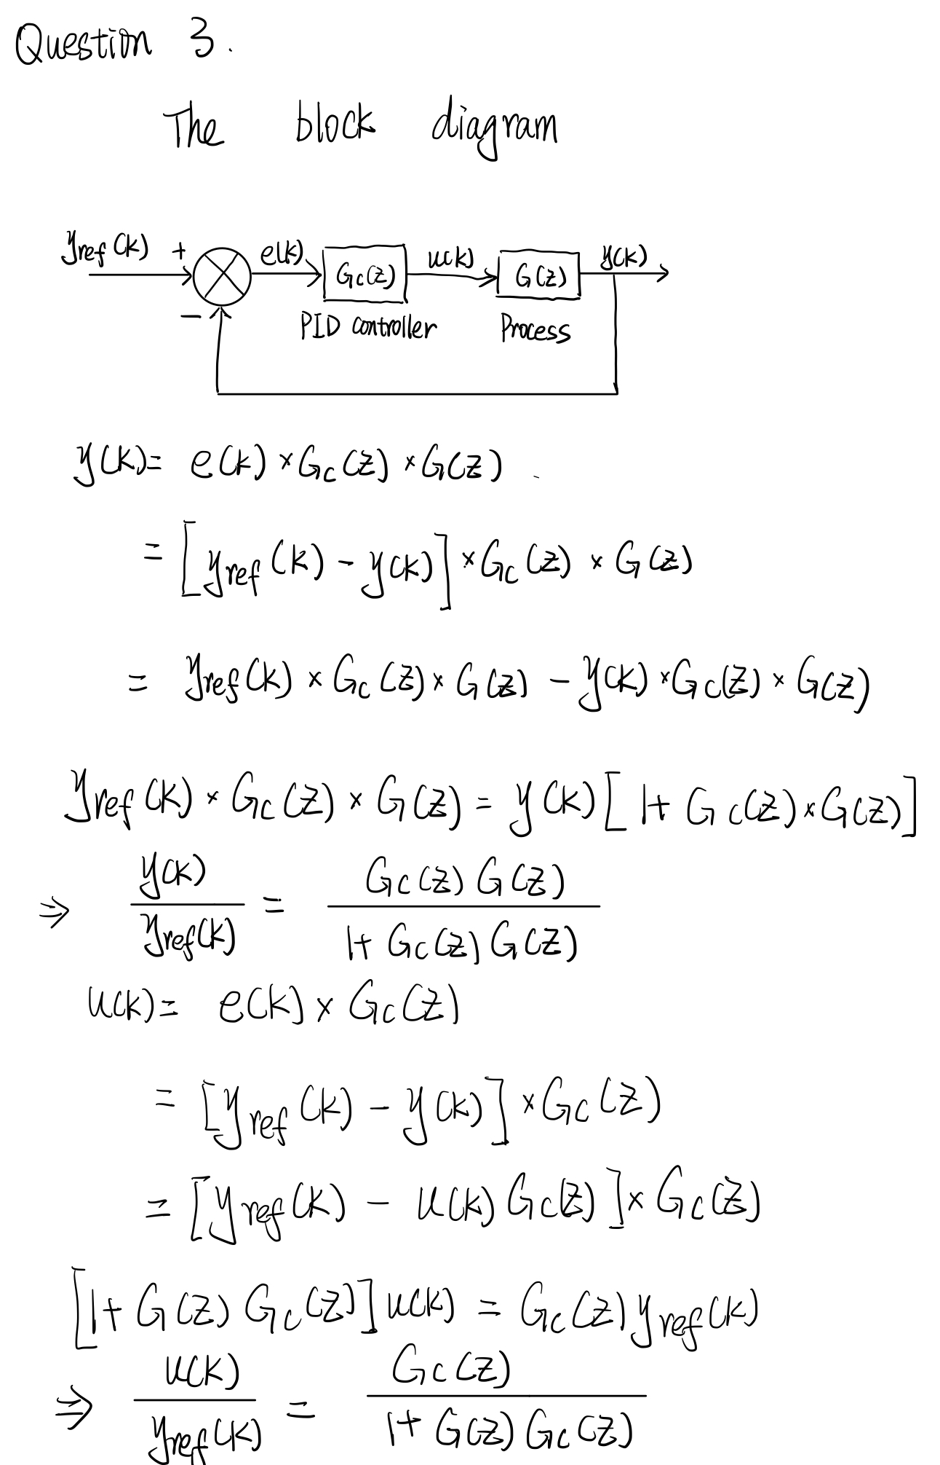

**Lab Exercise**

1. **System Identification**

Repeat the steps of Lab 2 and obtain the following parameters.

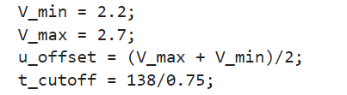

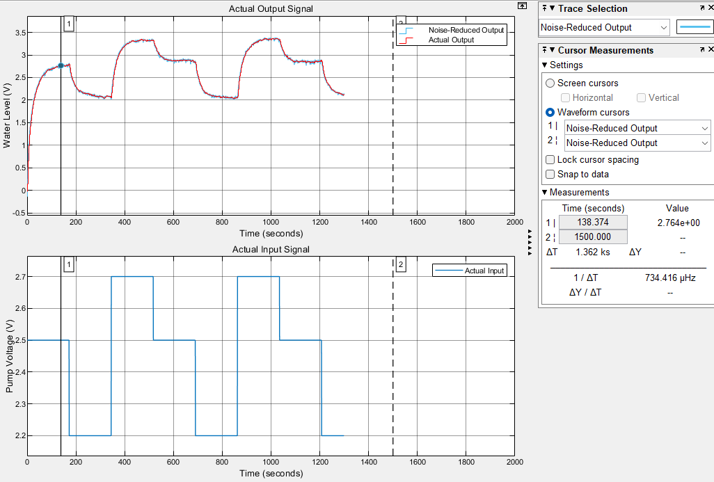

Figure 1. Collected Data

It can be observed from the generated plots that the simulated output tracks the actual output very well.

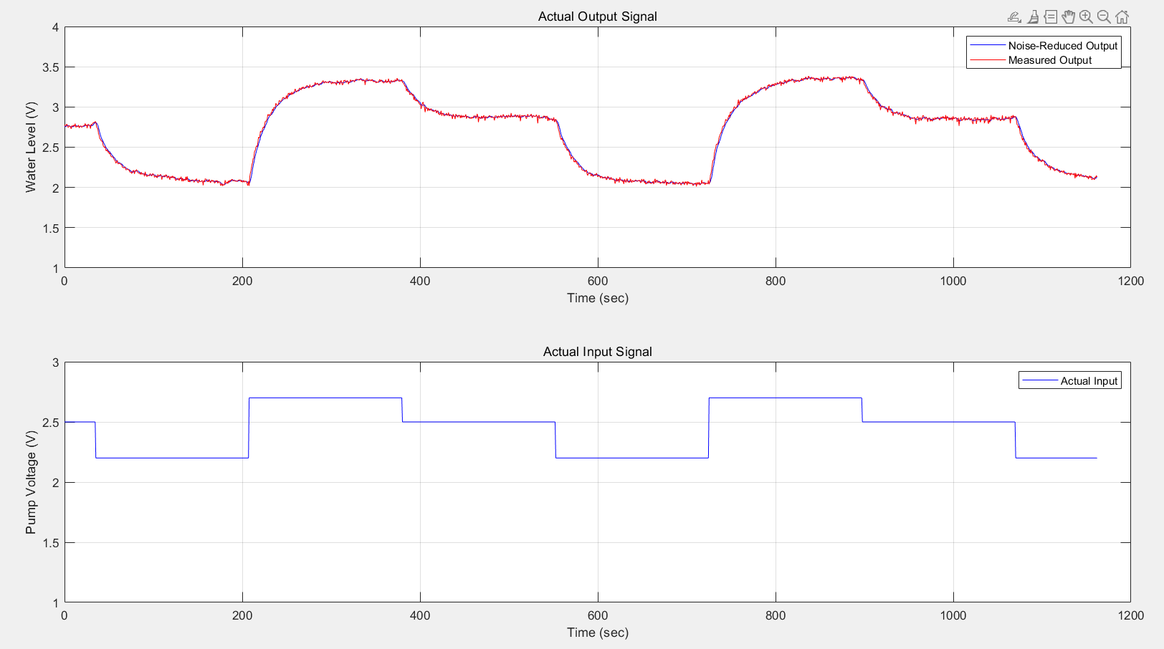

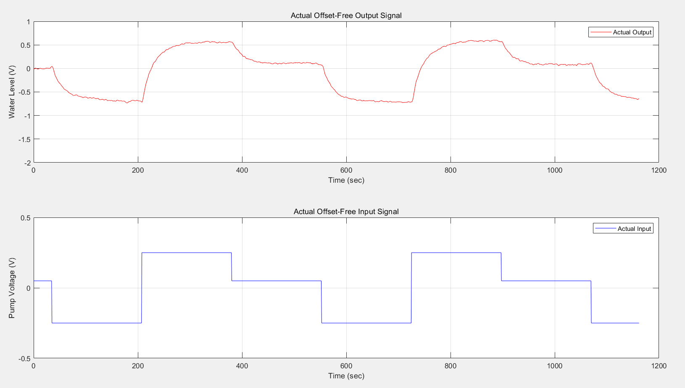

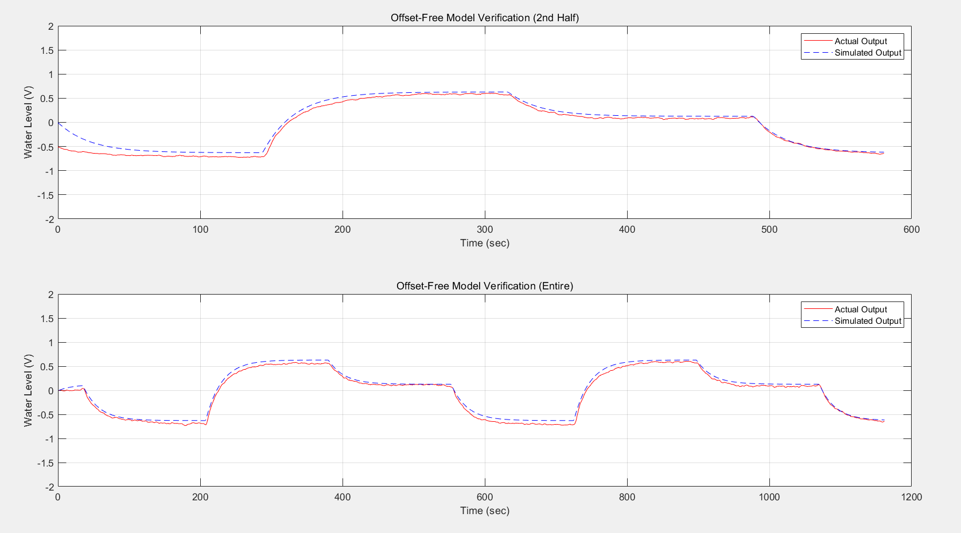

Figure 2. Results repeat Lab 2

1. **PI control design**

Here is the simulink model of PI control.

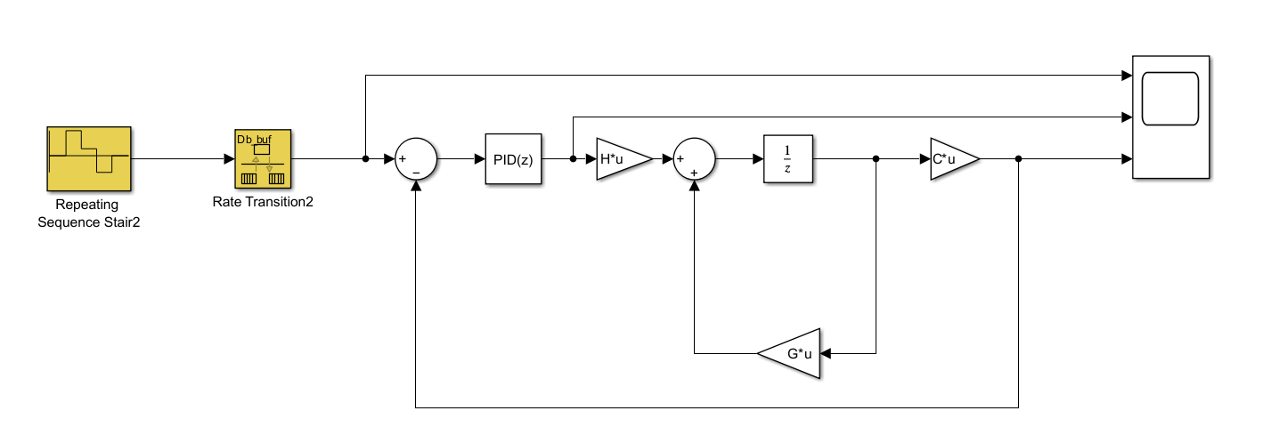

Figure 3. PI control model

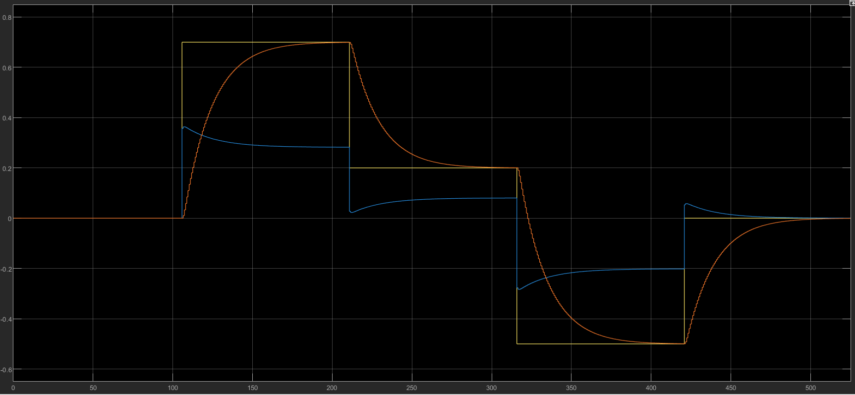

Figure 4. Input and Output of PI Controller

In our design, we used the trial-and-error approach to determine the values of Kp and Ki. After several adjustments, we obtained Kp = 0.51 and Ki = 0.022, which made the simulated output closely follow the reference signal.

1. **Real-time implementation of the control system**

After applying the designed control parameters and PI controller settings to the model and running the simulation, Figure 5 can be obtained. It can be observed that there is a significant deviation between the actual and simulated outputs in the initial stages. However, around 144s, the actual output begins to track the simulated output, proving that the PI controller can effectively control the system.

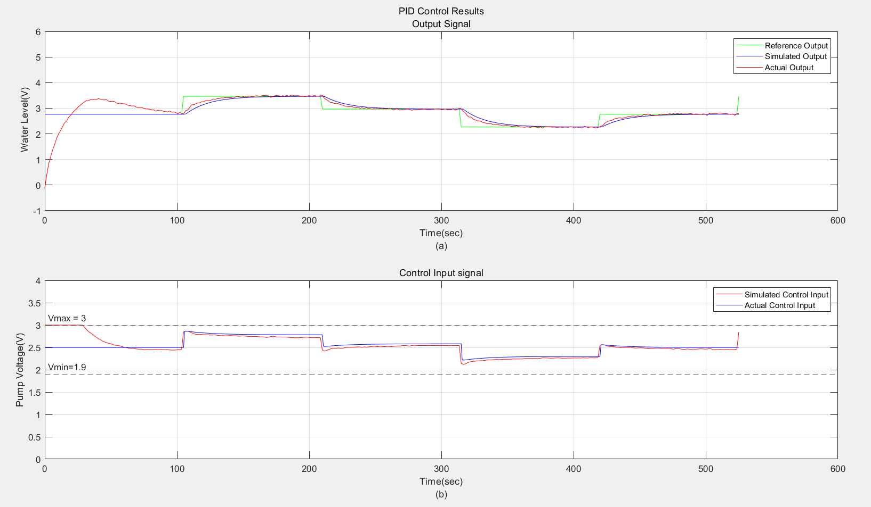

Figure 5. The control result of W-T system

**Optional as Bonus:**

At the beginning, there may be a significant deviation between the system's output signal and the reference signal, which is typically referred to as the initial transient behavior. This could be because, at the start of control, the system's output has not yet fully responded to the changes in the control input.

The control input saturation at the beginning occurs because the system needs to make a large adjustment in the early stage, and the controller's output signal exceeds the controller's output limit.

**Conclusion**

In this experiment, the PI controller was successfully designed using the trial-and-error method, with the gains Kp = 0.51 and Ki = 0.022. The system’s output closely tracked the reference signal, and the overshoot remained below 2%, indicating effective control. Initially, the control input was saturated due to large adjustments required, but the system stabilized as the output began to align with the reference. Overall, the PI controller demonstrated good performance, proving its ability to manage the system effectively.